Website Profile

Lucas is a graduate student in the Natural Resources and Ecology master’s program whose research focuses on the caloric availability for waterfowl in mitigated wetlands. He is passionate about restoring and preserving quality habitats for wildlife and public outreach. Outside of his research, Lucas enjoys playing the banjo, cooking, and all things outdoors.

Interests:

* Wetland Ecology
* Restoration Ecology
* Wildlife Ecology
* Ecosystem Services

Education:

MS Natural Resources & Ecology, 2023-

SUNY Plattsburgh

BS Mechanical Engineering, 2021

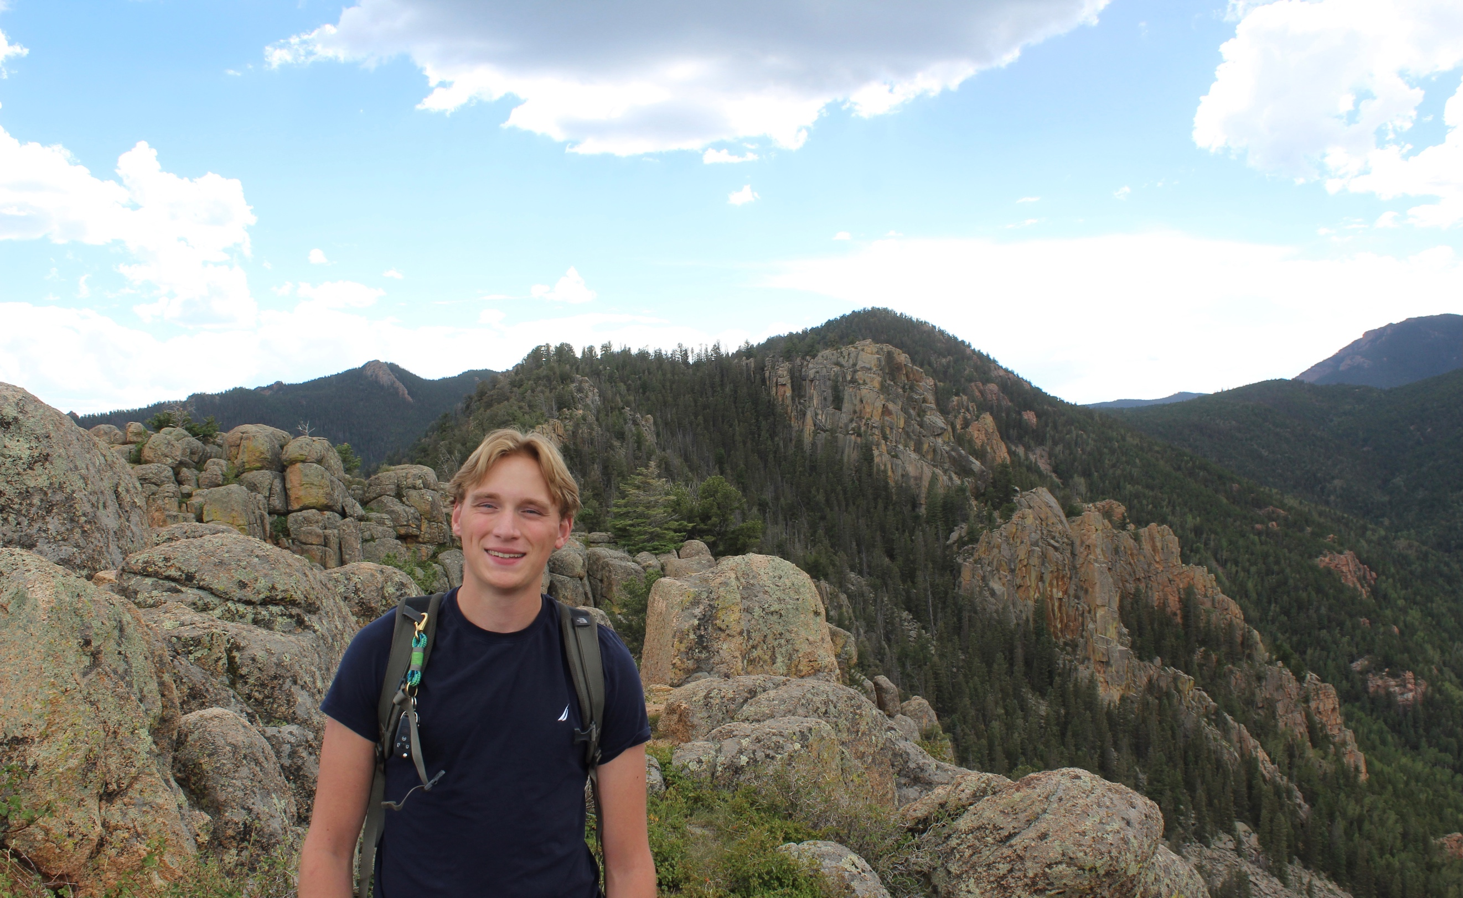 Binghamton University